Title (Times New Roman, 16pt., Bold)
Names of the authors (Times New Roman, 12 pt., Bold). Surnames must be capitalized. Corresponding author must be underlined.
1) Post address, email address (Times New Roman, 12 pt., regular) of the first author. Email address of the corresponding author must be underlined.
2) Post address, email address (Times New Roman, 12 pt., regular) of the second author.

Main text (Times New Roman, 12 pt., regular). The first line of each paragraph must be indented 12.5 mm. Single spaced.
Maximum extent size is 2 pages including spaces, heading, names address, body text, and figures. Abstract must be written in English. Authors are advised to prepare their abstracts using this template. The paper size is A4. The approximate standard is from 1 to 1.5 pages for the text and the number of the references should be minimized.

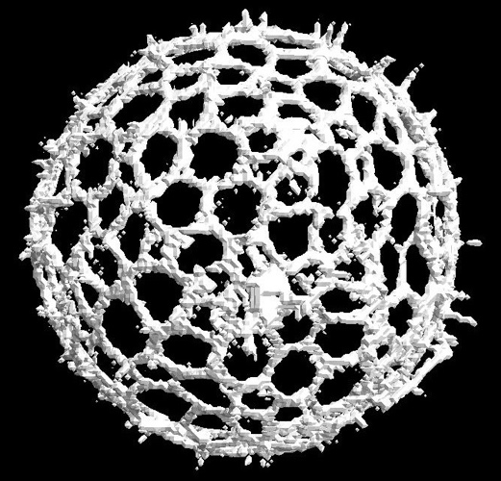
Figure 1. (Times New Roman, 10.5 pt., Bold) Caption is required. (Times New Roman, 10.5 pt., regular)
Figures are permitted. Color figure is acceptable. The caption is required for each figure. Please confirm the copyright material if necessary.
References (Times New Roman, 12 pt., Bold)
The references should be ordered alphabetically. (Times New Roman, 12 pt., regular)
Keywords: Must be contained more than 4 words

(The manuscript of following two pages is an example. )

Radiolarian biostratigraphy studies in the Neotethyan Ocean: A synthesis
Alan T. BAXTER¹, Jonathan C. AITCHISON¹ & Sergei V. ZYABREV²
1) School of Geosciences, University of Sydney, NSW 2006, Australia. alan.baxter@sydney.edu.au; jonathan.aitchison@sydney.edu.au
2) Institute for Tectonics & Geophysics, 65 Kim Yu Chen Street, Khabarovsk,
680000 Russia. sziabrev@gmail.com

The Yarlung Tsangpo suture zone (YTSZ) in Tibet contains the discontinuous and fragmented remains of the once extensive Neotethyan Ocean. These remains commonly include lower and upper crustal ophiolitic rocks and are commonly capped by deep-marine sediments. Many of these sediments contain the preserved tests of marine fossils, such as radiolarians. Using well-established biostratigraphic methods, the depositional age of these sediments can be accurately and confidently estimated. The age of deposition can help researchers to reconstruct the temporal and spatial extent of deep-water sedimentation in the Neotethyan Ocean. Furthermore, radiolarian-bearing sediments, deposited on the margins of this ocean, can be used to aid understanding of the paleogeographic environment. For example, Danelian & Robertson (1997) use radiolarians, extracted from the deep-water sediments of the Lamayuru Group in NW India, to reconstruct the tectonic and paleoceanographic evolution of the Indian passive margin.
Radiolarian studies have been undertaken in Tibet and India for over 30 years (Li & Wu, 1985; Wu, 1986; Kojima et al., 2001; Matsuoka et al., 2001; Liu & Aitchison, 2002; Wang et al., 2002; Ziabrev et al., 2004). However, to date no comprehensive review of work in this region has been compiled. These studies have greatly helped to re!ne the timing of deepwater- sedimentation in the Neotethyan Ocean and constrain the timing of oceanic crust, intra-oceanic island arc and subduction complex generation (Ziabrev et al., 2004; Baxter et al., 2011). This work aims to collate all of the radiolarian biostratigraphic studies that have been undertaken from Neotethyan Ocean samples. A comprehensive review of all the published radiolarians will be presented and a series of time slices that will incorporate both the depositional environment and the timing of sedimentation will be proposed. Their position within the context of a Neotethyan paleogeographic model will also be discussed.
References
Baxter A.T., Aitchison, J.C., Zyabrev, S.V. & Ali, J.R., 2011. Upper Jurassic radiolarians from the Naga Ophiolite, Nagaland, northeast India. Gondwana Research 20, 638–644.
Danelian, T. & Robertson, A.H.F., 1997. Radiolarian evidence for the stratigraphy and palaeo-oceanography of the deep-water passive margin of the Indian Plate (Karamba Formation, Indus Suture Zone, Ladakh Himalaya). Marine Micropaleontology 30, 171–195.
Kojima, S., Ahmad, T., Tanaka, T., Bagati, T.N., Mishra, M., Kumar, R., Islam, R. & Khanna, P., 2001. Early Cretaceous radiolarians from the Indua suture zone, Ladakh, northern India. News of Osaka Micropaleontologists, special volume 12, 257–270.
Li, H.S. & Wu, H.R., 1985. Radiolaria from the Cretaceous Congdu Formation in southern Xizang (Tibet). Acta Micropalaeontologica Sinica 2, 1, 61–76.
Liu, J.B. & Aitchison, J.C., 2002. Upper Paleocene radiolarians from the Yamdrok melange, south Xizang (Tibet), China. Micropaleontology 48, 145–154.
Matsuoka, A., Kobayashi, K., Nagahashi, T., Yang, Q., Wang, Y.J., Takei, M. & Zeng, Q.G., 2001. Early Middle Jurassic (Aalenian) radiolarian fauna from the Xialu chert in the Yarlung Zangbo Suture Zone, southern Tibet. In: Faunal and floral migrations and evolution in SE Asia-Australasia (Metcalfe, I., Smith, J.M.B., Morwood, M. & Davidson, I., Eds.), Balkeema Publishers, 105–110.
Wang, Y.J., Yang, O., Matsuoka, A., Kobayashi, K., Nagahashi, T. & Zeng, Q.G., 2002. Triassic radiolarians from the Yarlung Zangbo suture zone in the Jinlu area, Zetang County, southern Tibet. Acta Micropalaeontologica Sinica 19, 3, 215–227.
Wu, H.R., 1986. Some new genera and species of Cenomanian Radiolaria from southern Xizang (Tibet). Acta Micropalaeontologica Sinica 3, 4, 347–360.
Ziabrev, S.V., Aitchison, J.C., Abrajevitch, A.V., Davis, A.M. & Lo, H., 2004. Bainang Terrane, Yarlung-Tsangpo suture, southern Tibet (Xizang, China): a record of intra-Neotethyan subduction-accretion processes preserved on the roof of the world. Journal of the Geological Society, London 161, 523–539.”
Keywords: Tibet, Indeia, Australia

